Project I

User Stories

User Story I:

“As a user, I want to add a new product into the system.”

Case I: user adds new product into system.

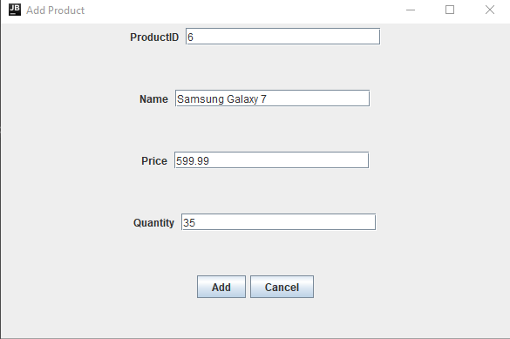

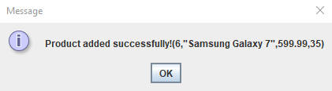

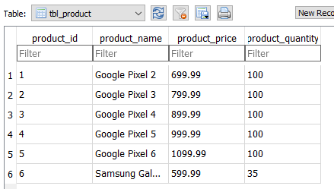

Case II: user adds a product that is already in the system.

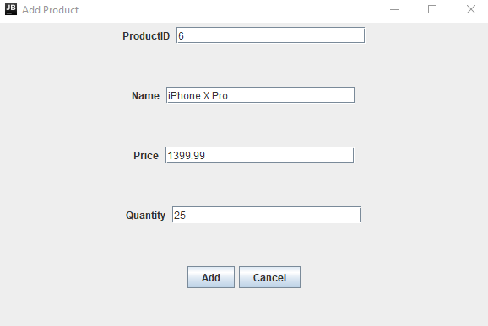

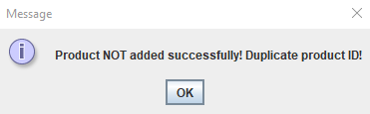



User Story II:

“As a user, I want to add a new customer into the system.”

Case I: user adds new customer into system.

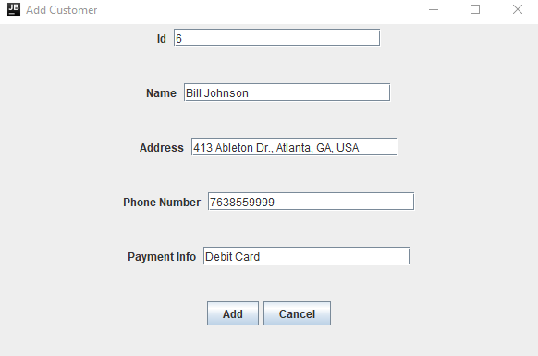

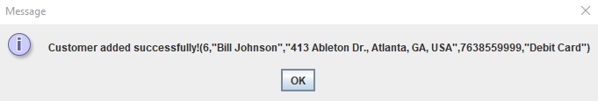

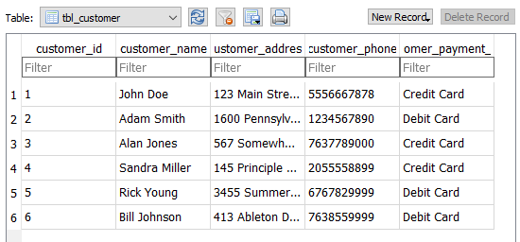

Case II: user adds a customer that is already in the system.



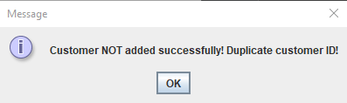



User Story III:

“As a user, I want to add a purchase from a customer into the system.”

Case I: user adds a customer purchase into the system.

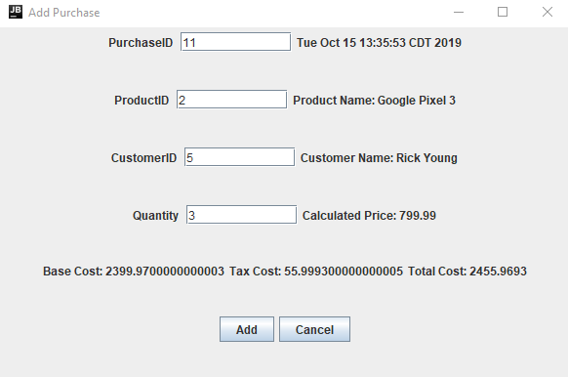

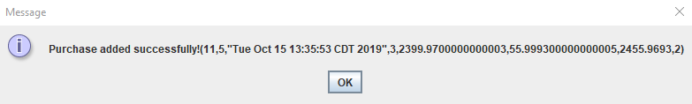

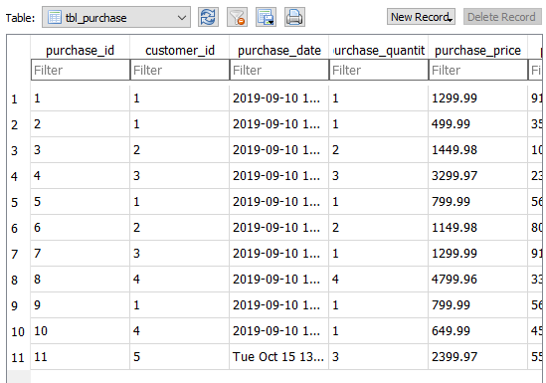

Case II: user adds a customer purchase that is already in the system.



